28. Develop a system using UML for Airplane Reservation System. The customer can search for flights for a given data and source/destination airport and reserve the required seats, the system should handle the payment. The customer can view flight schedules and cancel their reservation(s) if needed. Admin can add new aircraft, flights, and flight schedules. Admin can cancel any prescheduled flight and a notification should be sent to all stakeholders.

SEQUENCE DIAGRAM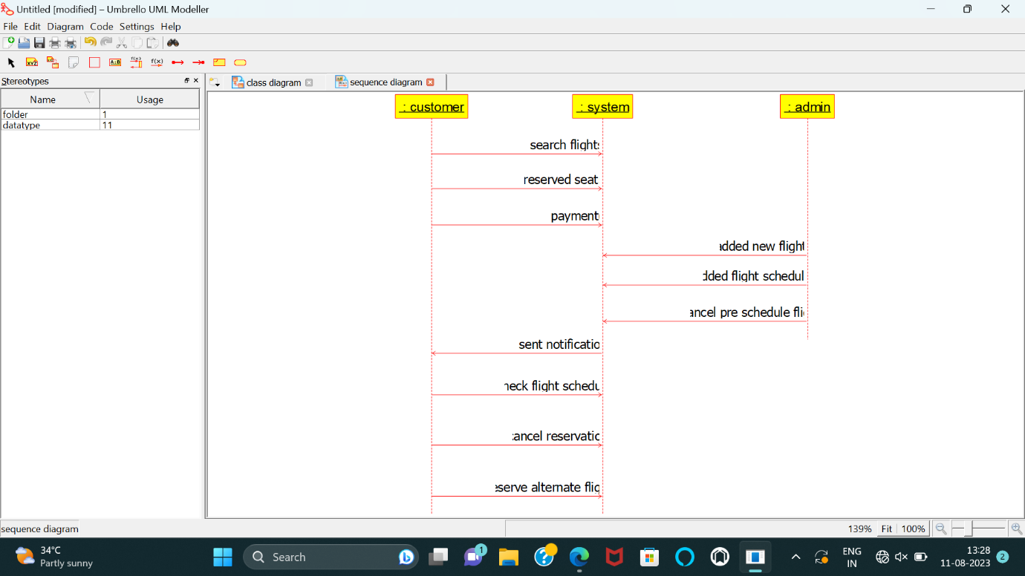

CLASS DIAGRAM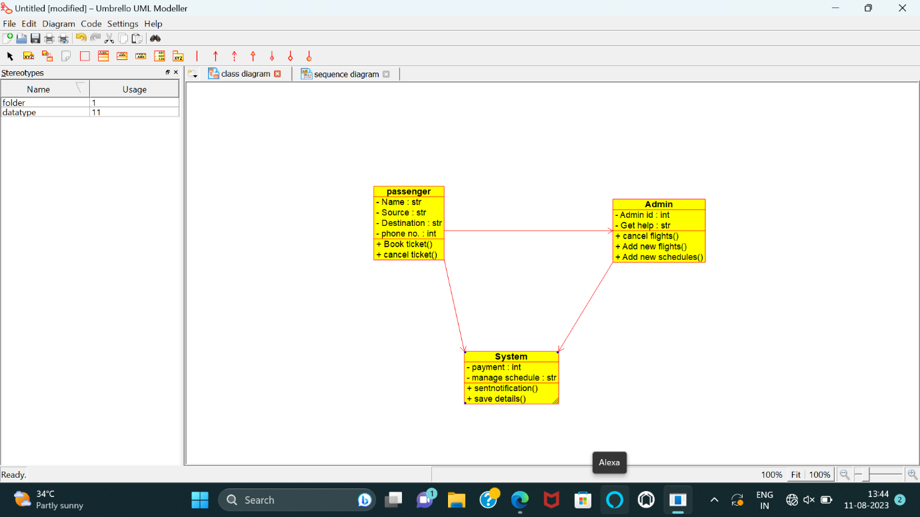

COMPONENT DIAGRAM

